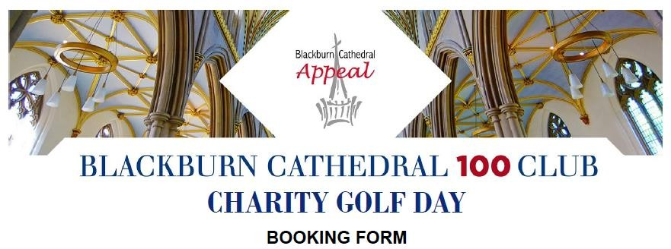

Tuesday 14th September 2021 at Clitheroe Golf Club

Arrival from 1130am for bacon sandwiches and coffee, tee off times from 1240pm until 3pm followed by a rolling buffet. There will be no formal dinner in the evening but there will still be prizes on the day, we plan to contact all of our golfers after the event with a virtual prize giving presentation.
Cost: Team of 4 people - £450

Company/Team Name: ……………………………………………………………………….

Address: ………………………………………………………………………………………..

…………………………………………………………………………………………………...

Postcode: ………………………………...............................................

Telephone Number: ……………………………………………………..

Email: …………………………………………………………………......

Contact Name on the Day: ……………………………………………...

Contact Telephone Number: ……………………………………………

We would like to book team(s) of 4 @ £450 per team

Method of payment:
- By cheque: (Please make cheque payable to ‘Blackburn Cathedral Trust’)

- By BACS Payment: NatWest Account Name: Blackburn Cathedral Trust Sort Code: 01 00 85
Account Number: 14578662 Ref: Golf Day

Blackburn Cathedral Trust is a reg charity: 1137237 Cathedral Office, Cathedral Close, Blackburn, BB1 5AA Tel: Ann Dean on 07710 500 802
Email: ann@ashfield.net

