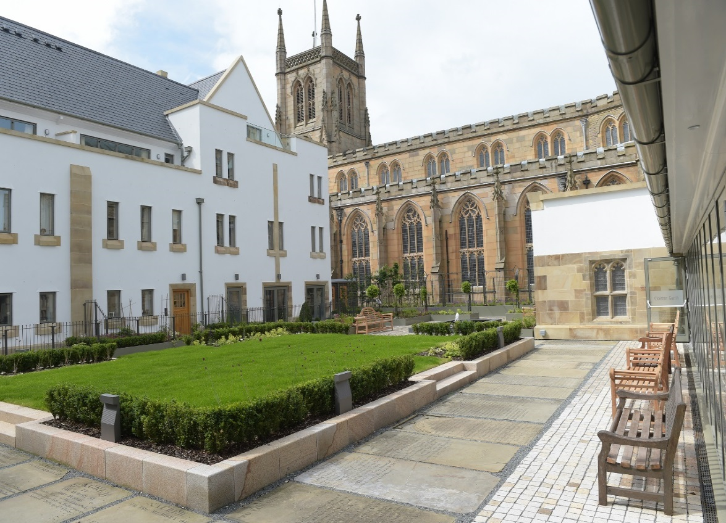

Application Pack

Director of Music

Introduction to Blackburn Cathedral

Blackburn Cathedral has a rich and fascinating heritage. It is a living community of prayer and worship, a centre of excellence in Church music, education and community engagement and plays a key role as the Mother Church of the Diocese of Blackburn for the Christian community across the whole of Lancashire. It is also the most prominent of Blackburn’s heritage assets and tourist attractions.

Blackburn Cathedral is a truly remarkable building. Reference to a church on the site is made in the Domesday Book, compiled in 1086, though other sources – the Saxon chronicle among them - would seem to support the long held belief that a church dedicated to St Mary can be dated to the year 596.

The Cathedral Church we know today is a development of the 1820-26 design built by John Palmer, when Blackburn emerged as the fulcrum of the industrial revolution. The early nineteenth century church was extensively rebuilt after a fire in 1831, and the bulk of it survives in the present structure as the western tower, nave and side aisles.

A century later, William Temple, then Bishop of Manchester, chose Blackburn as the focus for a new diocese. The church of St Mary was chosen to be the new cathedral and an extension scheme by William Adam Forsyth sought to take the building a stage further. Work started in 1928, and halted in 1941 during World War 2, began again with a reduced budget in 1951 but never finished Forsyth’s plans, which included a central tower of dominating Gothic proportions.

In 1962 Laurence King was appointed architect. His design for a concrete central corona reduced the buildings Gothic emphasis and was made ready for its eventual consecration in 1977.

But work never stops. The Archbishop of York, Dr John Sentamu visited Blackburn Cathedral in July 2016 to officially open the new Cathedral Court. The development is the first cloisters to be built at a UK cathedral for over 500 years and also marks the final portion of the large-scale regeneration of the areas around the Cathedral.

The new Cathedral Court includes residences for the Cathedral clergy and staff as well as a hall of residence for organ and choral scholars. It also includes new public gardens, a library, conference facilities, offices, parking and the new Temple Gallery that links the original Cathedral building to the new cloisters. The development has also created the opportunity to create new public areas and gardens that now links the Cathedral directly with a new Cathedral Square, with offices, restaurants and a hotel.

More details regarding the Cathedral may be found on our website: www.blackburncathedral.com

The Cathedral’s Mission and Strategy

In March 2017, our new Dean arrived bringing with him significant experience across the cathedrals world having previously worked at two cathedrals. Under his leadership, Chapter are currently developing a strategic plan to aid our future direction as a Cathedral community.

As part of this process the Cathedral Chapter are keen to work closely with the Diocese of Blackburn in helping to deliver 'Vision 2026: Healthy Churches Transforming Communities' and embracing it as part of their own mission strategy. http://www.blackburn.anglican.org/what-is-vision-2026

It has been said many times that Blackburn Cathedral punches well above its weight and the delivery of Cathedral Court is testimony to this. We continue to be ambitious in our thinking and have a high aspiration for the future. One of our strategic priorities is to recruit an outstanding Director of Music, who will be willing to play a full part in cathedral life and hold a significant leadership role within the life of the community. As disciples of Jesus, how we form ourselves as community and work together as colleagues has an important impact on communicating the gospel we proclaim.

Music at Blackburn

Music and Mission Engagement

Worship is one of seven elements within our Strategic Plan and the role of music cannot be overestimated in the contribution it makes to the wider cathedral mission. Whilst our current patterns of worship are well established, Chapter are committed to exploring new and creative ways of engaging beyond the fringes of the cathedral. It is expected that the new Director of Music will play a significant part in helping to develop the musical reach of the cathedral.

Choirs and Organs

As one of the younger Cathedrals of England, we are justifiably proud of our musical tradition which has developed significantly during the last twenty years. There are now seven choirs at the Cathedral: The Cathedral Choir, the Cathedral Girls’ Choir, the Young People’s Choir, The Renaissance Singers, Lantern Voices, Schola Cantorum and the Cathedral Consort. In addition to this, there are three Choral Scholars and an organ scholar. The Music Outreach Programme began in 2006 and is led by Gill Fourie, Head of Music Outreach.

All the members of the Choirs (with the exception of the Choral Scholars) are voluntary. The boys and girls are drawn from a variety of schools in the area and the Director of Music is responsible for the overall recruitment and development the choirs.

Tours have been an important feature of the Cathedral Choir, Girls’ Choir and the Young People’s Choir experience over the years, visiting such places as the USA, Prague, Braunschweig, Berlin, Prague and Paris.

The Cathedral Choir is presently made up of 16 Boys and 12 Choirmen (including 3 Choral Scholars). The gentlemen and the boys in some cases travel considerable distances to rehearsals and services. The full Choir sings twice on Sundays and the Boys currently sing Evensong on alternate Fridays . There is no Choir School. Most boys are educated locally and links with these schools are essential.

The Cathedral Girls’ Choir, is presently 16 in number. This choir has been developed to a very high standard over the past 12 years. The Girls’ Choir sings Choral Evensong on Tuesday.

The YPC (Young People’s Choir) sings at the Parish Eucharist every Sunday in term-time and sings services and concerts in the Diocese. The young people are drawn from ex-choristers and a number of schools in the area.

Schola Cantorum is a group made up of Choral Scholars and boys from the Young People’s Choir, directed by the Assistant Director of Music. This choir currently sings Choral Evensong on Wednesday in term time, and takes part in other special services, such as the Advent Procession.

The Cathedral Consort is a group of men and women drawn from a number of choirs, directed by the Director of Music, who sing Choral Evensong on most Thursdays in term-time.

The Renaissance Singers is an independent Chamber Choir of 37 men and women. This choir regards the Cathedral as ‘home’ and gives concerts and sings some services during the year. Singing is of a high standard and this is well recognised throughout the North West Region, including amongst the broadcasting authorities. The Director of Music is appointed independently to this role and is paid by the Renaissance Singers an additional fee for directing this choir.

Lantern Voices is essentially a non-liturgical choir of boys and girls aged between 7 and 11, led by Gill Fourie, occasionally singing at special services and concerts (e.g. the Crib Service and Mothering Sunday). Currently the choir numbers 20 children and meets once a week (on Thursdays).

We are keen to develop further our music ministry and work beyond the cathedral and Chapter will be interested to hear of applicants’ ideas as to how they might develop an already outstanding musical offering and extend our reach further into the wider community.

The Organs

Blackburn Cathedral is blessed with a world-class Organ, built in 1969 by JW Walker to a design by Francis Jackson and John Bertalot. It is an outstanding recital and liturgical instrument with an excellent portable console. It was reconstructed and enlarged in 2001 by Wood of Huddersfield. It is regarded as one of the finest of its genre in the country. For comprehensive information please see the Cathedral web site https://www.blackburncathedral.com/wp-content/uploads/2016/05/Blackburn-Cathedral-Organ-Specification.pdf .

The Cathedral also has a four-stop Chamber Organ designed and built by Kenneth Tickell in 2001 (Stopped Diapason 8, Principal 4, Chimney Flute 4 and Fifteenth 2).

There are 2 Song Schools in the Cathedral Crypt. The newly refurbished main Song School comprises: song room with a Weber grand piano (2008), robing room and well stocked choir library. The YPC Vestry is smaller and is often used for individual singing tuition.

The Cathedral also has a fine Yamaha Grand Piano and a harpsichord.

The Music Department

The Music Team is the largest department in the Cathedral and includes the following personnel:

Dean & Chapter

Liturgy Assistant
Part-time
Canon Sacrist

Music Assistant
Part-time

Director of Music

Assistant Director of Music

Choral/Organ Scalars x4
Head of Music Outreach
Choirs & Choristers

Music Outreach Team

Management and Governance
The Director of Music is appointed by the Chapter of Blackburn Cathedral. The Canon Sacrist is the Chapter representative in the Music Department and as such is the line manager of the Director of Music. Together with the Canon Sacrist, the Director of Music is responsible to the Dean for all music in the Cathedral, whether liturgical or non-liturgical. As a member of the Senior Executive Team, the Director of Music is appraised annually by the Dean.

The Director of Music manages and appraises the professional staff of the Music Department: The Assistant Director of Music, The Music Administrator, singing tutors, Organ Scholar and Head of Music Outreach. The Director of Music is also responsible for appraising the Choral Scholars and the Choirmen.

The Director of Music chairs a monthly Music Staff Meeting, regular meetings with the Choirmen and termly Music Outreach Programme meetings. He also attends a Chorister Parents Meeting (termly), chaired by the Canon Sacrist, the Senior Executive Team (weekly), and Diary (weekly) meetings. The Director of Music currently reports to Chapter annually, and attends or sends a deputy to all special service and concert planning meetings.

The Cathedral’s Under 18’s safeguarding lead is Mrs Denise Sanderson. She is supported by the Cathedral Safeguarding Group, chaired by the Canon Missioner. This group advises the Chapter on Safeguarding matters across all areas of Cathedral life. The Director of Music is responsible for safe recruitment and ensuring safe working practices in the Music Department, where the well-being and safety of the Choirs is the first priority of all staff.

Job Description

Job Title: Director of Music

Responsible to: The Dean

Line Manager: The Canon Sacrist

Role Purpose

The Director of Music is responsible for the oversight and high-quality musical leadership of sung worship across the many services at the Cathedral. A well developed understanding of how music serves the worship of the church and communicates the gospel it serves is essential.

Key Responsibilities

- The person

Chapter seeks to appoint an accomplished Christian musician who:

- Is passionate about and has proven experience in recruiting and training boy and girl choristers to the highest of standards
- Is able to inspire, motivate and enthuse the children and adults who contribute to the voluntary music making across cathedral worship
- Has proven skill as a choral and orchestral conductor
- Is a talented organists (at least FRCO standard) who has a flair for liturgical accompaniment and interpretation
- Has an extensive knowledge of the repertoire of the English Choral Tradition and its place within the evolving liturgy and tradition within the Church of England
- Has a lively Christian faith, a communicant member of their own denomination and is familiar with and comfortable to worship within the Church of England
- Is IT competent, administratively proficient and able to plan effectively and work to deadlines
- To act as an ambassador for Blackburn Cathedral, representing the foundation in a positive and proactive way, consistent with the values and ethos of the Cathedral.

- The role

- In collaboration with the Canon Sacrist, to ensure that music is well rooted in the cathedrals wider mission strategy and to ensure its ongoing development
- To have overall responsibility for the recruitment and training of the cathedral choirs and to ensure the highest musical standard across all choral services
- In partnership with other members of the music team, to be responsible for the rehearsals of all the cathedral choirs, the induction and training of choristers, and the development of the skills of the Choirmen (all voluntary), Choral and Organ Scholars
- To ensure that adequate cover is provided for additional services throughout the year
- To oversee the music library and to ensure maintenance, cataloguing and the purchase of new music
- To attend and contribute to the cycle of cathedral and departmental meetings including weekly Senior Executive meeting, diary meetings and Music Department meetings chaired by the Canon Sacrist
- To play the organ to the highest of standards
- To have primary responsibility for the discipline of all within the music team – Choristers, Scholars, Choirmen and colleagues
- To be able to contribute and to work comfortably alongside those who come offering music of a more contemporary nature, particularly at Diocesan events
- To be responsible for arranging or giving the ‘in house’ concerts and other musical/choral events including weekly Wednesday organ recitals
- To ensure that the cathedral’s organs and other instruments are maintained and tuned
- To be Artistic Director and a member of the Council of the Friends of Blackburn Cathedral Music
- To oversee the Music Outreach Programme and line manage the Head of the programme
- To take an active part in the musical life of the Diocese, acting as a resource for the Bishop, an ambassador for the cathedral and its music, and support parish organists where requested
- In partnership with the Canon Sacrist and or Canon Pastor, to take part in the pastoral oversight of the Choristers and staff
- To arrange for the Cathedral Choirs to sing in parish churches across the Diocese from time to time

- Administration and Finance

- To administer the department efficiently, working with part-time administrative support
- In consultation with the Canon Sacrist, to prepare the quarterly music schemes, yearly calendar and rotas
- To oversee and manage the work of the Assistant Director of Music and Scholars, and to oversee the annual appraisal of staff within the department
- To ensure positive team working across the department and to unite the team around the cathedral vision and strategy
- To propose policies for choir tours, recordings and special events
- To contribute to Chapter discussion on all matters of the cathedral’s music activities and to prepare reports for and to attend meetings of Chapter as and when required
- To ensure all contractual and financial arrangements of music staff are efficiently conducted in partnership with the Executive Director and Finance Officer
- To ensure that agreed music focused fundraising targets are met in accordance with Chapter’s Financial Improvement Plan
- Working with other staff across the cathedral community to ensure a fully supported and committed cathedral team who communicate well across all departments in helping to realise our strategy for growth
- To develop and update policies relevant to the work of the Director of Music, in line with good practice, legislation and Chapter recommendations.

- Recruitment and Development

- To develop the next generation of musicians will be an important aspect of the role. Therefore, a robust and creative approach to the on-going recruitment of Choristers from schools across the local area.
- To ensure vacancies for Choirmen, Choral and Organ scholars, and other staff are recruited using safe recruitment processes
- Regularly to audition potential deputy singers and maintain a list of approved deputies
- To approve the music and musical competence of visiting choirs and groups invited to lead worship during choir holidays and to ensure that one of the Cathedral Music Team are available to play if a visiting choir does not have a suitably proficient accompanist.

- Safeguarding

- To be fully conversant with the Cathedral’s Safeguarding Policy and to ensure that at all times appropriate procedures are followed to safeguard children, vulnerable adults and the Cathedral Chapter
- To monitor and when necessary check that members of the music department are conversant and compliant with Chapter policy

Additional Information

Salary
The salary will be £30,000 per annum.

Accommodation
A substantial four-bedroom townhouse is provided within the newly constructed Cathedral Court for the better performance of duties.

Contract
The employer is Blackburn Cathedral on a permanent contract.

Hours
As a Senior Director, the remuneration is such as to expect the post holder to work such hours and times as to fulfil the duties of the position – an average of at least 40 hours per week. Weekend work and out of hours work will be required.

Place of Work
Blackburn Cathedral Office, Cathedral Close, Blackburn, BB1 5AA

Probation
The position is subject to a six-month probationary period, during which the appointment may be terminated by either party with one month’s notice. After the successful completion of the probationary period the notice period is three months’ notice on either side. A formal review will be carried out at the end of the probationary period.

Benefits
28 days’ holiday per year plus UK Bank Holidays, outside of choir term for which the normal rate of salary will be paid. Holiday leave will run from 1 January each year and leave will be authorised by the Canon Sacrist.

Entitlement to join the Cathedral pension scheme with the Chapter contributing 5% of gross monthly salary.

Expenses
Reasonable working expenses will be met in line with Chapter policy.

Office and Administrative Support
A desk is provided for the Director of Music within an open plan office.

Work in a private capacity.
The Dean and Chapter wish to encourage the Director of Music to become a pivotal person in the musical life of the County, Region and Nation. They also wish to maintain a post with a proper balance between, on the one hand, the Director of Music’s primary responsibility to the Cathedral and the Cathedral’s wider ministry and on the other hand, enabling the Director of Music to pursue outside musical interests such as teaching, organ recitals and conducting. Any outside engagement which may involve a clash of interests can only be undertaken with the prior approval of the Canon Sacrist and the provision of acceptable cover.

Blackburn Cathedral is an equal opportunity employer.

Applications

Applicants are invited to submit, with reference to the above job and person specification:

- a letter of application, indicating why you think you should be considered for this post and what gifts and skills you would bring.

The letter of application should be accompanied by:

- a completed Blackburn Cathedral Application form – please feel free to add pages if necessary.

- the names of three referees (one of whom must be a clergyperson) including your present employer if applicable. Referees will not be contacted until short listing has taken place.

- the Declaration enclosed in this pack regarding working with children and young
people, which must be signed and returned with the application. The successful candidate will be offered the post conditionally until a satisfactory DBS certificate has been received.

- Applications should be returned to:

Mrs Pauline Rowe
Executive Assistant to the Dean
Blackburn Cathedral Office
Cathedral Close
Blackburn
BB1 5AA

pauline.rowe@blackburncathedral.co.uk

Tel. 01254 277431

If you would like to make an informal visit to the Cathedral please contact the Dean’s Executive Assistant.

